Project Intervene
Prepared by the Owners Corporation

Further information about Project Intervene can be found on our webpage at https://www.nsw.gov.au/project-intervene

Address: Click or tap here to enter text.Strata Plan No: Click or tap here to enter text.

For the best outcome, please add all of the documents and information that you have for your building. This includes:
- Documents and information about the building. Project Intervene looks only at “serious defects” in the “key building elements” of the common property. Focus your reply on those defects.
- Consent by the owners corporation for access to information held by the council and others. This will enable us to get more documents to improve the outcome.
- A defects report to be completed with the information you hold about defects. If you do not have expert reports at all, or about all of the serious defects, complete it as much as possible, adding photos of what is observed (photos should indicate as much information as possible about where they are taken such as the level, and whether it is north south east or west etc).
- Provide the documents and information held about the building
Planning approvals and consent documents (if available – if not available add “NA”)
- Development application | Choose an item.
- Construction certificates / complying development certificate | Choose an item.
- Occupation certificate | Choose an item.
Subdivision and Stata Plan
- Plan of subdivision and strata plan | Choose an item.
- Strata (or Building) Management Statement (if any) | Choose an item.
Serious defects
- Any known serious defects in the common property of the building (structure, waterproofing, fire safety, building envelope/cladding and building services) including any specialist reports related to those defects | Choose an item.
Building condition / orders
- Development control order, Fire safety order or any correspondence from Council relating to any non-compliance (if any) | Choose an item.
- Recent Annual Fire Safety Statement | Choose an item.
- Any notice or correspondence from Fire & Rescue NSW relating to fire safety non-compliance | Choose an item.
Insurance
- Building insurance policies (i.e. replacement, public risk etc.) including any notifications made to the insurer regarding the existence of combustible cladding or building defects | Choose an item.
Remediation of serious defects already underway
- Any reports about serious defects that you have no more than 5 years old | Choose an item.
- Any signed contracts in relation to remediation work | Choose an item.
- Copy of any remediation plans in relation to any works being undertaken or proposed to be undertaken in the building | Choose an item.
- Details of any interim safety measures implemented at the building (e.g. propping) | Choose an item.
Litigation
- Any litigation that may be on foot (what is the claim; which court, who is the other party to the claim, the status of the litigation, a copy of the statement of claim; name and contact details of solicitor and firm acting for the owners corporation and the name of the firm acting for the other side) | Choose an item.

Developer Name:  Address:  Contact details: | Click or tap here to enter text.  Click or tap here to enter text.  Click or tap here to enter text.
Builder Name:  Address:  Contact Name:  Contact details: | Click or tap here to enter text.  Click or tap here to enter text.  Click or tap here to enter text.  Click or tap here to enter text.
Certifier Name:  Contact Details: | Click or tap here to enter text.  Click or tap here to enter text.
Strata Manager Name: (individual)  Company Name:  Contact Details: | Click or tap here to enter text.  Click or tap here to enter text.  Click or tap here to enter text.
Names of former Strata Managers  Contact Details: | Click or tap here to enter text.  Click or tap here to enter text.

Strata Committee Owners Consent

I, Click or tap here to enter text.an authorised representative of the
(name)
Strata Committee of Strata Plan Click or tap here to enter text., give consent to
(SP number)
an Employee of the Office of the Building Commissioner, NSW Department of Customer Service or any contractor engaged for or on behalf of the Office of the Building Commissioner, NSW Department of Customer Service with respect to coordinating activities in relation to Project Intervene to obtain, collect and store information and documents relevant to

Click or tap here to enter text.
(address of building)

from local councils or any other relevant entity which may hold relevant information and documents.

Serious defects in the building elements identified by the owners corporation
(an example is included as a guide below)

Address: Click or tap here to enter text. Strata Plan No: Click or tap here to enter text.

1.0 Key Building element - Waterproofing
Item | Location | Serious defect Description | Photograph
1.1 | Click or tap here to enter text. | Observation:  Click or tap here to enter text.
1.2 | Click or tap here to enter text. | Observation:  Click or tap here to enter text.
1.3 | Click or tap here to enter text. | Observation:  Click or tap here to enter text.

2.0 Key Building element – Fire Safety Systems
Item | Location | Serious defect Description | Photograph
2.1 | Click or tap here to enter text. | Observation:  Click or tap here to enter text.
2.2 | Click or tap here to enter text. | Observation:  Click or tap here to enter text.
2.3 | Click or tap here to enter text. | Observation:  Click or tap here to enter text.

3.0 Key Building element – Structural System

Item | Location | Serious defect Description | Photograph
3.1 | Click or tap here to enter text. | Observation:  Click or tap here to enter text.
3.2 | Click or tap here to enter text. | Observation:  Click or tap here to enter text.
3.3 | Click or tap here to enter text. | Observation:  Click or tap here to enter text.

4.0 Key Building element – Building Enclosure / External Cladding.
If your building has registered for Project Remediate, please include this
Item | Location | Serious defect Description | Photograph
4.1 | Click or tap here to enter text. | Observation:  Click or tap here to enter text.
4.2 | Click or tap here to enter text. | Observation:  Click or tap here to enter text.
4.3 | Click or tap here to enter text. | Observation:  Click or tap here to enter text.

5.0 Key Building element - Essential Services (eg lift, drainage, electricity, switch room, fire pump etc)
Item | Location | Serious defect Description | Photograph
5.1 | Click or tap here to enter text. | Observation:  Click or tap here to enter text.
5.2 | Click or tap here to enter text. | Observation:  Click or tap here to enter text.
5.3 | Click or tap here to enter text. | Observation:  Click or tap here to enter text.

Below are examples on how to complete the form about serious defects you know of
2.0 Fire Safety Systems
Item No | Location | Description | Photograph
2.1 | Whole building | Observed that penetrations in service cupboards appear to be stopped with standard building foam rather than appropriate fire stopping. This appears to be systemic throughout the building. | 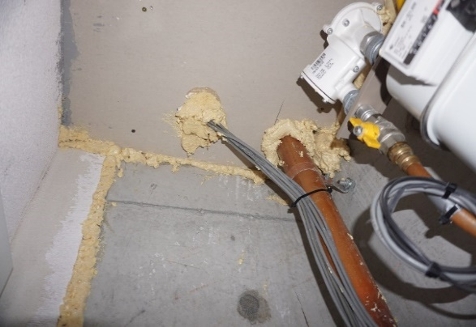  Photo location  EXAMPLE
3.0 Structural Systems
Item No | Location | Description | Photograph
3.1 | Basement 2 | Observed significant cracks on vehicle entry driveway. | 